[Insert institution Name here]  Form Template | Form No.: Personnel-1
[Insert institution Name here]  Form Template | Revision No.:
Title: SAMPLE LABORATORY ORGANIZATION CHART | Approval Date:

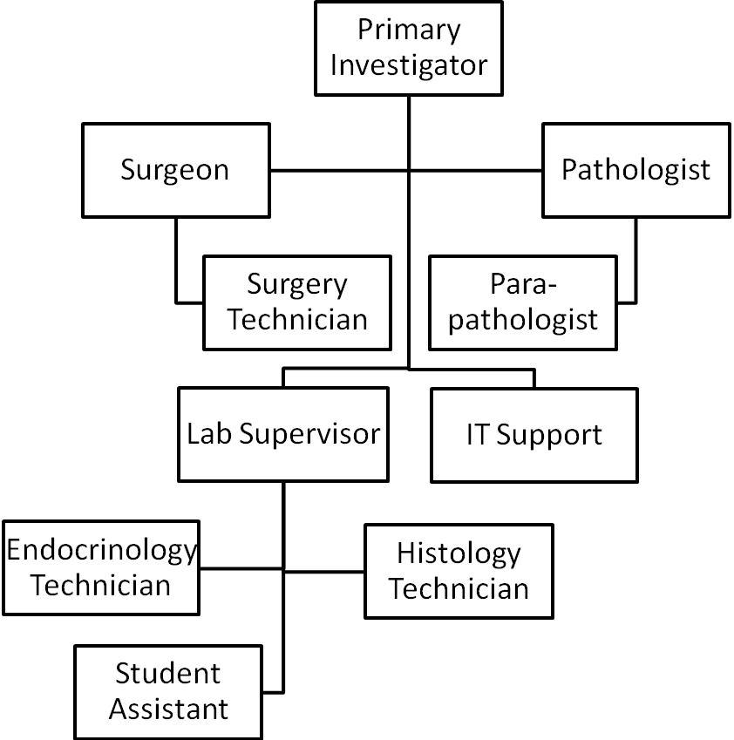
HOW TO USE THIS TOOL:
- [in each box] Record name and role for each person who contributes significantly to the study, and show reporting lines for each.
- Ensure that each person has a job description, a resume/CV, and a training record.
- Post this chart in the laboratory or area where most of the research is performed.

WHY DO THIS?
- The chart clarifies reporting lines to all personnel involved in the project.
- The chart can be used by auditors to quickly understand who does what.

[Insert Company Name here]  Form Template | Form No.: Personnel-2
[Insert Company Name here]  Form Template | Revision No.:
Title: SAMPLE EMPLOYEE JOB DESCRIPTION FORM  (not a substitute for the institutional job description form) | Approval Date:

Employee Name: | Job Title:
Hire Date: | Supervisor Name:

Job Duties:
Add job duties here

(i.e. Monitor and collect accurate data for laboratory animal charts)
(i.e. Prepare and administer oral medication to research animals, circulate in animal surgeries and assist in post-operative care)
(i.e. Prepare and maintain hard copy study records)
(i.e. Perform data entry into the computer)
(i.e. Perform radioimmunoassay for testosterone)
(i.e. Perform nucleic acid extraction)
(i.e. Perform PCR reaction set up)

Include if Appropriate:

Quality Assurance Duties: (Such as “maintain required documentation of work procedures that includes proper use of laboratory notebook, documentation of data, and adherence to laboratory SOP’s.”)

Safety: (Such as “employee is trained to follow the laboratory safety plan for use of radioisotopes.”)

HOW TO USE THIS TOOL:
- Ensure that each job description reflects job duties required by the project.
- Review the job description annually and update as needed.

WHY DO THIS?
- An accurate job description documents the understanding of job tasks by both employee and supervisor.
- An accurate job description emphasizes the importance of QA and Safety responsibilities to both the employee and supervisor.

[Insert Institution Name here]  Form Template | Form No.: Personnel-3
[Insert Institution Name here]  Form Template | Revision No.:
Title: SAMPLE STAFF RESUME TEMPLATE FORM | Approval Date:

RESUME

Name & Title:

Contact Information:

Education:
(List schools, dates attended, graduation date, degrees awarded, majors and minors in chronological order, i.e. California State University, Fresno – 1991 – Masters Degree – Biology.)

Professional Experience:
(List employment for the past three years, in chronological order)
- Employer-Job Title- Dates of Employment-Brief Work Description
- Employer-Job Title- Dates of Employment-Brief Work Description
- Employer-Job Title- Dates of Employment-Brief Work Description

Special Skills:
Laboratory information database, quality management software, skill 3, skill 4

Accomplishments/Publications: (Optional)

Training: (Optional)

Memberships in Professional Organizations: (Optional)

HOW TO USE THIS TOOL:
- Ask each staff employee to create a resume and update it annually.

WHY DO THIS?
- The resume documents credentials of participants in the project.

[Insert Institution Name here]  Form Template | Form No.: Personnel-4
[Insert Institution Name here]  Form Template | Revision No.:
Title: SAMPLE FACULTY CURRICULUM VITAE TEMPLATE FORM | Approval Date:

CURRICULUM VITAE

Name and Title:

Contact Information:

Education:
(List schools, dates attended, graduation date, degrees awarded, majors and minors i.e., in chronological order)

Professional Experience:
(List employment for the past three years, in chronological order)
- Employer-Job Title- Dates of Employment-Brief Work Description
- Employer-Job Title- Dates of Employment-Brief Work Description
- Employer-Job Title- Dates of Employment-Brief Work Description

Honors:

Membership in Professional Organizations:

Funded Research Projects:

Presentations at Scientific Meetings:

Publications:

HOW TO USE THIS TOOL:
- Ask each faculty/professional employee to create a curriculum vitae and update it annually.

WHY DO THIS?
- The curriculum vitae documents credentials of participants in the project.

[Insert Institution Name here]  Form Template | Form No.:Personnel-5
[Insert Institution Name here]  Form Template | Revision No.:
Title: SAMPLE NEW EMPLOYEE TRAINING CHECKLIST  (not a substitute for the institutional new employee training checklist) | Approval Date:

New Employee Training Checklist

Laboratory Supervisor: __________________ Laboratory Name: _____________________

Review job description for accuracy.

Review the nature of the research and the hazardous components of the research in the lab
- _____ Chemical
- _____ Biological
- _____ Radiation
- _____ Physical

Review laboratory safety
  - ______ Discussion of basic laboratory safety rules
  - ______ Location and use of PPE (safety glasses/goggles, lab coats, gloves)
  - ______ Location of hazardous chemicals
  - ______ Proper use of compressed gases
  - ______ Proper handling of sharps / broken glass
  - ______ Proper use of laboratory specific equipment

Review and location of
- ______ Laboratory Safety Plan
- ______ Standard Operating Procedures (SOP)
- ______ Material Safety Data Sheets
- ______ Hazardous Chemical Waste Management Guidebook
- ______ Chemical waste disposal procedures and sites

Emergency equipment location / procedures
- ______ Telephone and emergency contacts
- ______ Exits
- ______ Fire extinguishers
- ______ Eyewash and emergency shower

Other items discussed / reviewed:
____________________________________________________________________________________
All personnel working in the laboratory must know and understand the hazards, follow safety guidelines applicable to the procedures being conducted, and assure that safety precautions are in place prior to starting the work.

Employee Name (print): _____________________________________ Date: _______________

Employee Signature: ________________________________________ Date: _______________

Trainer / Supervisor: _________________________________________ Date: _______________

WHY DO THIS? The checklist identifies laboratory hazards and safety information for employee information, and documents new employee training in these areas.

[Insert Institution Name here]  Form Template | Form No.: Personnel-6
[Insert Institution Name here]  Form Template | Revision No.:
Title: SAMPLE SIGNATURE AND INITIALS IDENTIFICATION LOG | Approval Date:

section | room # | printed name | printed initials | signed initials | signature | date

HOW TO USE THIS TOOL:
- Ask each employee who is responsible for recording data to provide a sample signature and initials for the log.
- Review the log annually to be sure that it is up to date.

WHY DO THIS?
- The log permits identification of employee by signature and/or initials in tracking data, documents, equipment maintenance, methods validation and training records.

[Insert Institution Name here]  Form Template | Form No.: Personnel-7
[Insert Institution Name here]  Form Template | Revision No.:
Title: SAMPLE QUALITY ASSURANCE RESPONSIBILITY CONTACT LIST | Approval Date:

Section | QA Role | Name | Phone # | Cell # | E-mail
Administration | Maintain laboratory org chart
 | Maintain job descriptions, resumes & CV’s
 | Maintain employee training records
 | Maintain equipment inventory logs
Endocrinology | Record sample storage freezer daily temperatures
 | Maintain equipment maintenance forms
 | Maintain assay validation data
Pathology | Maintain specimen access, tracking and storing logs
 | Maintain necropsy records for test laboratory animals

HOW TO USE THIS TOOL:
- Record contact person and contact information for each QA responsibility that is critical to the project.
- Post this table in the laboratories or areas where most of the research is performed.

WHY DO THIS?
- Project personnel are reminded of the QA roles that are critical to the project.
- Project personnel can quickly identify responsible individuals for personnel, data, document or equipment updates.
- The table can be used by auditors to quickly understand who does what.

[Insert Institution Name here]  Form Template | Form No.: Personnel-8
[Insert Institution Name here]  Form Template | Revision No.:
Title: SAMPLE PERSONNEL TRAINING & COMPETENCY RECORD | Approval Date:

Employee Name_____________________________________ Start Date__________________________ Supervisor Review _____________________________________________________________________

Section/Procedure | Review Procedure |  | Demonstrate/Practice |  | Competency Met
Section/Procedure | Date | Trainer  Initials | Date | Trainer  Initials | Date | Trainer  Initials
General Procedures/Policies
- Personnel Standards
- Laboratory Security
- Laboratory Cleaning
- Laboratory Safety and personal protective equipment
- Equipment manuals and management
- Sample identification, handling, and tracking.
Research Quality Assurance Practices
- Use of SOPs and document/version control
- Data/record error correction
- Laboratory notebook use
- Equipment management and monitoring
- Quality control records
- Method validation
- Data and sample archiving
Endocrinology/Hormone Measurement
Testosterone Radioimmunoassay (RIA) method
- Quality Control
- Preventive Maintenance
- Calibration
- Reporting Test results
- Trouble shooting errors
Cortisol Chemiluminescence method
- Quality Control
- Preventive Maintenance
- Calibration
- Reporting test results
- Trouble shooting errors

WHY DO THIS? This form can be used to provide documentation of employee training, demonstration of competencies, and identification of the trainer(s).

[Insert Institution Name here]  Form Template | Form No.: Personnel-9
[Insert Institution Name here]  Form Template | Revision No.:
Title: SAMPLE EMPLOYEE EQUIPMENT TRAINING RECORD | Approval Date:

Equipment | Employee read manual and knows its location. | Employee understands safety instructions. | Employee demonstrated proper operation/use | Comments/References
 | Employee initials  Trainer initials  Date | Employee initials  Trainer initials  Date | Employee initials  Trainer initials  Date
 | Employee initials  Trainer initials  Date | Employee initials  Trainer initials  Date | Employee initials  Trainer initials  Date
 | Employee initials  Trainer initials  Date | Employee initials  Trainer initials  Date | Employee initials  Trainer initials  Date
 | Employee initials  Trainer initials  Date | Employee initials  Trainer initials  Date | Employee initials  Trainer initials  Date
 | Employee initials  Trainer initials  Date | Employee initials  Trainer initials  Date | Employee initials  Trainer initials  Date
 | Employee initials  Trainer initials  Date | Employee initials  Trainer initials  Date | Employee initials  Trainer initials  Date
 | Employee initials  Trainer initials  Date | Employee initials  Trainer initials  Date | Employee initials  Trainer initials  Date
 | Employee initials  Trainer initials  Date | Employee initials  Trainer initials  Date | Employee initials  Trainer initials  Date
 | Employee initials  Trainer initials  Date | Employee initials  Trainer initials  Date | Employee initials  Trainer initials  Date
 | Employee initials  Trainer initials  Date | Employee initials  Trainer initials  Date | Employee initials  Trainer initials  Date
Note: This form is referenced in Procedure Base Training SOP

WHY DO THIS? This form can be used to provide documentation of employee training, demonstration of competencies, and identification of the trainer(s) for research equipment.

